Xoel Não Vivo - Nova Linha vivo

Tim

(13) 98312-6527 - ;change-number 5514983126527

{"intent": "intent.trigger.altas.pos"}

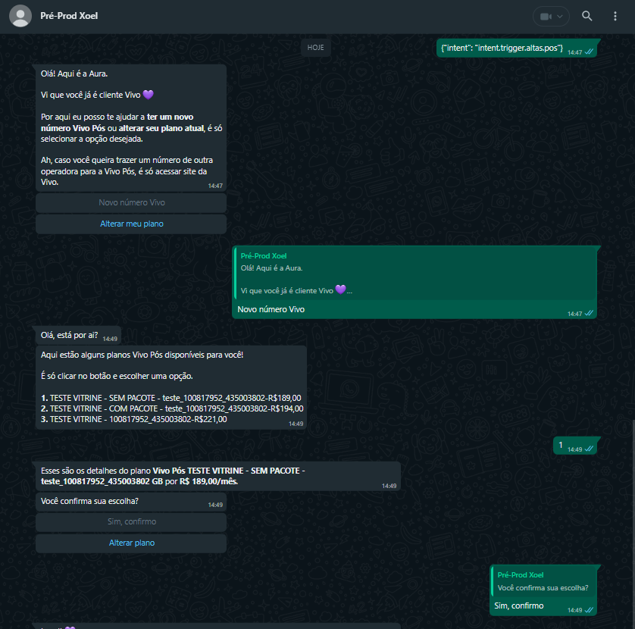

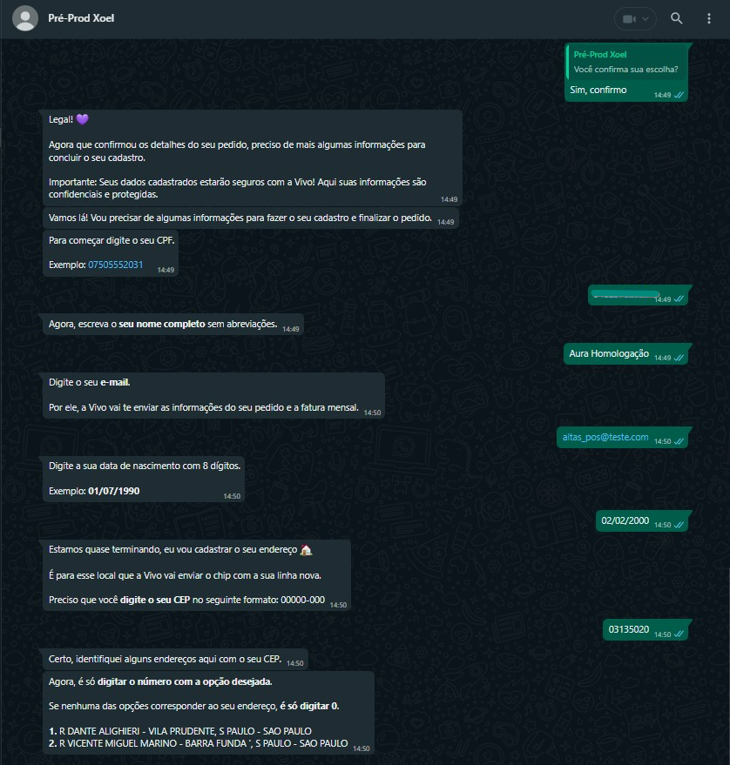

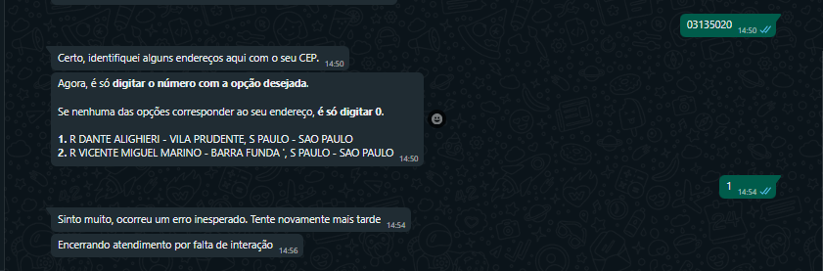

Teste 2



